1. Patient Age

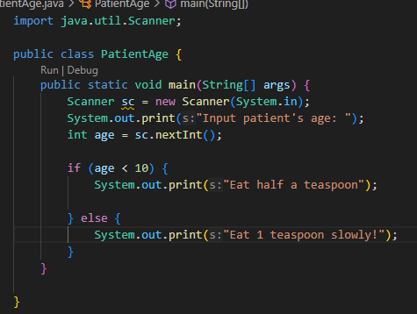

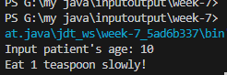

2. calculate depreciation

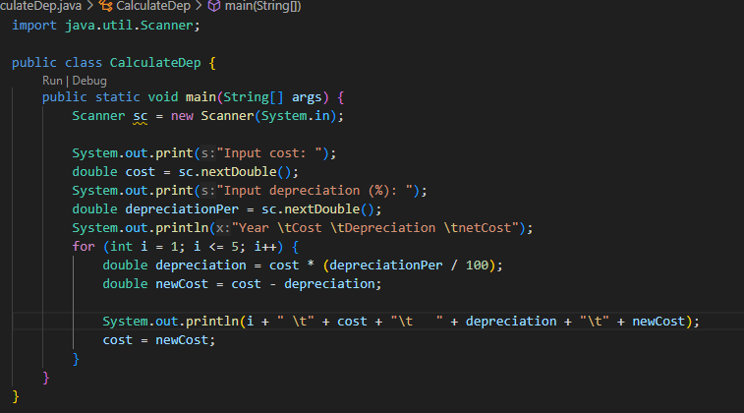

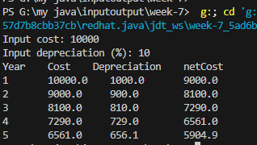

Group Name- Core i9

Name - Sai Lin Htet

Id- 6807665

Name – La Yaung Moe

Id- 6807688